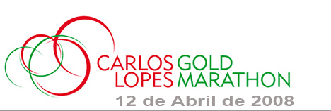

Dear Athlete,

It is with our great pleasure that we are sending you confirmation of your registration to the “Carlos Lopes Gold Marathon’ 08, on April, 12

You can pick up your bib under presentation of this letter, at the Race Expo, “Pavilhão de Portugal” Expo’98, Lisboa,

The race Expo is open on 10 and 11 of April from 10:00pm to 08:00pm and Saturday 12th April from 10:00am until 01:00pm
Transports: the Metro (Subway) station Oriente, or bus to the same station. (Shopping Center Vasco da Gama)
The Marathon will take place on Saturday 12 of April. Start at 04:30pm, as well as the Mini Marathon race
The race starts will take place in front the zoological gardens in the quarter of "Sete Rios". Accessible by the Subway of the same name
The finish line is installed in the park ''Parque Expo ' 98''.
The Organizing Committee of “Lisboa Gold Marathon” thanks you for choosing our event and wishes you a very good luck for your race.

Best Regards
Antonio Agostinho

The Organizing Committee
Carlos Lopes Gold Marathon

Athlete’s Name: Mr Steffen UMLAUF (Germany)
Bib number: 5258 Marathon
E-mail: zenon.karczewski2@dresdner-trolle.de









